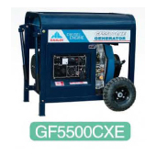

It's the parts that make or break an engine.That's why we fit our products with advanced oil pumps and atomizers for better diesel burning,resulting in generators that are 10percent more efficient than the same models on the market.since we use bearings from japan's top engine parts maker as well as utilize balanced shafts,our products have low friction and vibration,and are easier to start-features your customers will appreciate.

MAJOR PRODUCTS:

HL2500CL,HL2500CLE,HL2500CX,HL2500CXE,HL4000CL, HL4000CLE,HL4000CX,HL4000CXE,HL5500CL,HL5500CLE,HL5500CX,
HL5500CXE,GF5500CXE
POWER OUTPUT:1.8KW—5.5KW
ENGINE SPEED:3000RPM,3600RPM
RATED VOLTAGE:
110V,120V,220V,230V,240V,110V/220V,120V/240V
RATED FREQUENCY:50HZ,60HZ

